# ASSIGNMENT 1

1. SDLC

Software development life cycle is a structured process that is used to planning, implementation, testing, documentation, deployment, and ongoing maintenance and support. The life cycle define a methodology for improving the quality of software and overall development process.

## 2. SOFTWARE TESTING

Software testing is a process used to identify the correctness, completeness and quality of developed computer software. the process checks whether the actually software matches the expected requirements and ensures the software is bug free. The process of software testing is to identify the error, fault, or missing requirements in contract to actual requirement

# SDLC PHASES AND ITS INTRODUCTIO

There are 6 phases of SDLC which are given below:

### phases 1: requirement collection

### phases 2: analysis

### phases 3: design

### phases 4: implementation

### phases 5: testing

### phases 6: maintenance

REQUIREMENT: gathering maximum information from the client about requirement for the product. The main goal of this stage is that everyone understand even minute detail of the requirement.

There are two type of requirement:

1. functional requirement
2. non-functional requirement

ANALYSIS: the analysis phases define the requirement of the system , independent of how these requirement will be achieve and maping the requirement into architecture.

DESIGN: in design phase creating a pre-production version of product according the requirement which is given by client and the pre-production can give the team the opportunity to visualize what the product will look like.

IMPLEMENTATION: the team should bulid exactly what has been requested, through there is still room for innovation and flexibility. The implementation phase deal with issue of quality, performance, and debugging.

TESTING PHASE: before getting the software product out the door to the production environment, it important to have your quality assurance team perform validation testing to make sure it is functioning properly.

MAINTENANCE: maintenance is the process of changing a system after it has been deployment.

Updating all analysis, design and user documentation.

# 4.AGILE METHODOLOGY

The agile methodology is a project management approach that involve breaking the project into phases and emphasis continuous collaboration and improvement. the team follow a cycle of planning, executing and evaluation. Generally agile is combination of iterative and incremental process models. this process has started early in the software development and started becoming popular with time due to its flexibility and adaptability.

# 5.AGILE MENIFESTO PRINCIPLE

Some principles of agile manifesto are given below:

1. individual and interaction
2. working software
3. collaboration between business people and developer
4. responding to change

# 6 WHAT IS SRS

SOFTWARE REQUIREMENT SPECIFICATION IS A COMPLETE SPECIFICATION AND DESCRIPTION OF REQUIREMENT OF THE SOFTWARE THAT NEED TO BE FULFILLED FOR THE SUCCEFULLY DEVELOPMENT OF THE SOFTWARE SYSTEM. THESE REQUIREMENT CAN BE FUNCTIONAL AS WELL AS NON-FUNCTIONAL DEPENDING UPON THE TYPE OF REQUIREMENT.

# 7.WRITE PHASE OF SPRIAL MODEL

4 phase of spiral model is given below:

1.planning: determination of objective, alternatives and constrains.

2.risk analysis: analysis of alternatives and resolution of risk.

3. engineering: development of the product.

4.customer evaluation: assessment of the result of engineering.

# 8.EXPLAIN PHASES OF WATERFALL MODEL

There are 6 phases of waterfall model which are given below:

1.REQUIREMENT GATHERING: this is first phase of waterfall model where the client has to provide the requirement for the system software.it is important that the requirement should be correct, and it form the basis for everything that will be done in all following phases of the project. When using the waterfall model, it is not possible to come back to the requirement and change them at a later stage, therefore this step is very important.

# 2.ANALYSIS: the software requirements that were obtained from the client are analysed that how the requirements have completed

# 3.DESIGN: design architecture document, implementation plan and the design team can now expand upon the information which was given in requirement document.

4.IMPEMENTATION: in the implementation phase, the team should build exactly what has been requested by the client and implementation code. the implementation phase deals with the issues of the quality, performance and debugging.

5.TESTING PHASE: in software engineering testing is the process of enhancing and optimizing deployed software as well fixing defects.

6.MAINTENANCE: maintenance phase is the phase which come after deployment of the software into the field.

In maintenance there is configuration and version management, redesigning and refactoring and updating all analysis.

# 9.WORKING METHODOLOGY OF AGILE MODEL AND WRITE PROS AND CONS:

Agile SDLC model is a combination of iterative and incremental process models with focus on process adaptability and customer satisfaction by rapid delivery of working software product.

The agile process is started early in the software development and started becoming popular with time due to its flexibility and adaptability. method breaks tasks into smaller iterative, or parts do not directly involve long term planning. After each iteration working software build is delivered. Each build is incremental in term of features; the final build holds all the features required by the customer.

## PROS OF AGILE MODEL:

1.it is very realistic approach to software development

2.promote team working and cross training.

3. anytime changes are acceptable.

4. it reduce total development time.

5.frequent delivery.

6.resource requirement are minimum.

## CONS [DISADVANTAGES OF AGILE MODEL]

1.due to lack of proper documentation, once the project completes and the developers allotted the project to new team member may be quite challenging.

2.not suitable for handling complex dependencies.

3.more risk of sustainability, maintainability and extensibility.

4.depends heavily on customer interaction, so if customer is not clear, team can be driven in the wrong direction.

# 10. WHAT IS OOPS

OOPS is an object- oriented programming system is based on the concept of objects. software is design by using objects that interact with one another object by sending messages.an object is look like a black box it means internal data is hidden.

For example: the phone has accessories like ram, rom…. etc are hidden under phone body.

# 11.basic concept of oops.

Basic concept of oops are given below:

1.object

2.class

3.encapsulation

4.inheritance

5.polymorphism

6.abstraction

# 12.what is object.

- instances of an object

- its same as class member

- using new keyword and constructor through create object

# 13.what is class.

Class is collection of data member(variable) and member function (method, process) with its behaviour.

# 14.what is encapsulation.

Encapsulation is the practice of including in an object everything needs hidden from other object. The internal state is usually not accessible by other object.in simple language we can say that the process of wrapping up of data (properties) and behaviour(method) of an object into a single unit and the unit here is a class or interface.

# 15.what is inheritance

inheritance means that one class inherit the characteristics of another class.it means inheritance is the process of forming a new class from an existing class and the existing class is class base class, new class is formed called as derived class. One of the useful aspects of object- oriented programming is code reusability.



There are mainly 5 type of inheritance:

1.single: only one parent having only one child

2.multilevel: single inheritance having one more another child.

3.hierarchical: one parent having 2 or more child.

4.multiple: java does not support.

5.hybrid: java does not support directly.

# 16.WHAT IS POLYMORPHISM.

The word polymorphism is derived from Greek word which mean “having multiple forms”. The polymorphism in java is a concept by which we can perform a single action by different way.

There is two type of polymorphism in java.

1.compile time polymorphism(overloading)

2.runtime polymorphism (overriding)

# 17. DRAW USECASE ON ONLINE BILL PAYMENT SYSTEM ( PAYTM ).

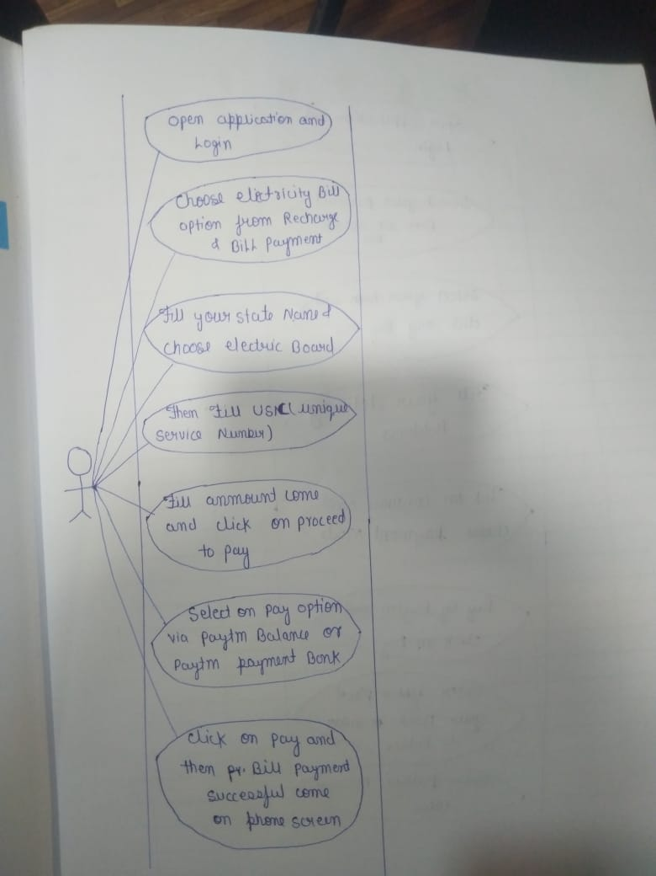

# 18.DRAW USE CASE ON ONLINE SHOPPING PRODUCT USING COD.

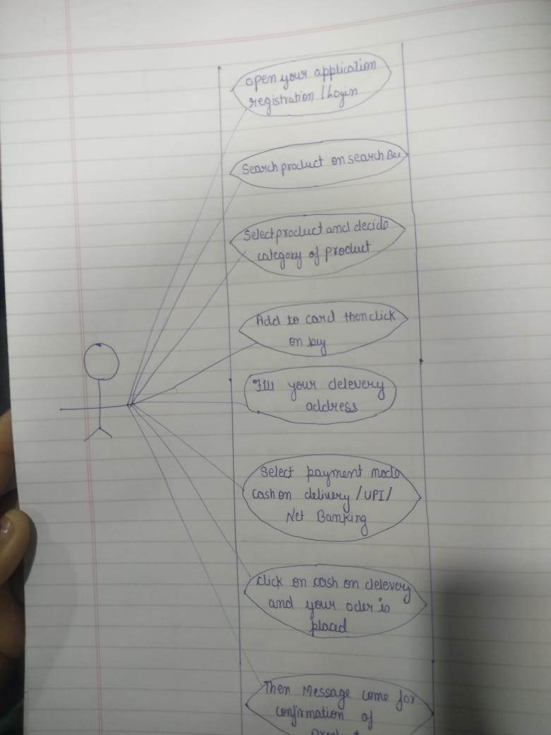

# 19. DRAW USE CASE ON ONLINE SHOPPING PRODUCT USING PAYMENT GATEWAY.

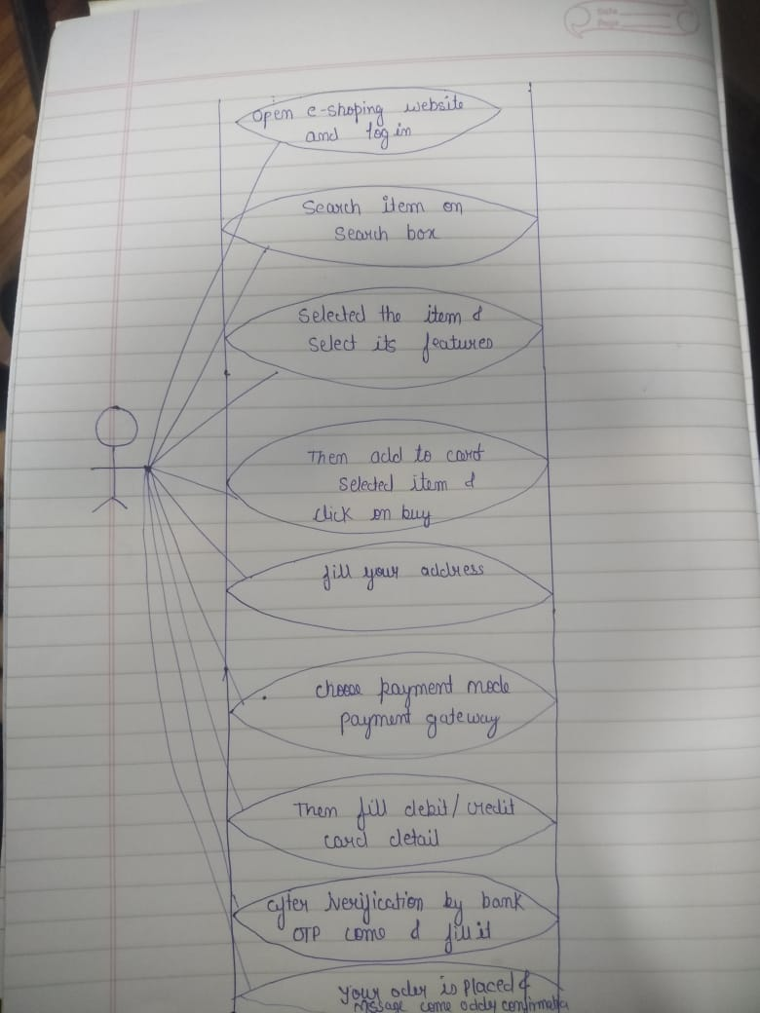

# DRAW US ECASE ON ONLINE BOOK SHOPPING.

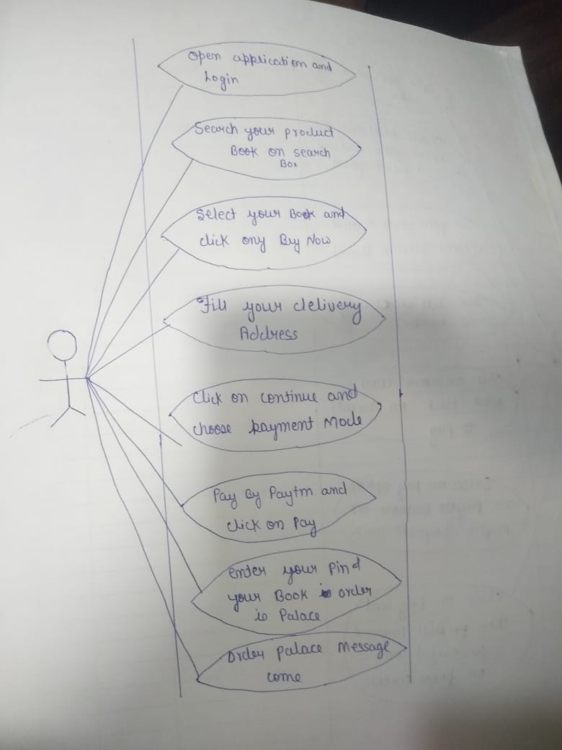

## COMPLETED ASSIGNMENT 1